
Sukkur Institute of Business Administration University Department of Computer Science
Java OOP(Lab)
BS – II Spring-2025

Lab #10

Instructor: Nimra Mughal
Section BSCS Ai-B
Submitted By: Azhar Ali Soomro
CMS: 023-24-0521

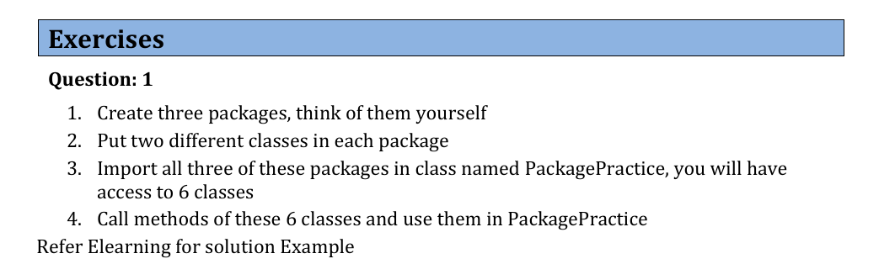
Code:
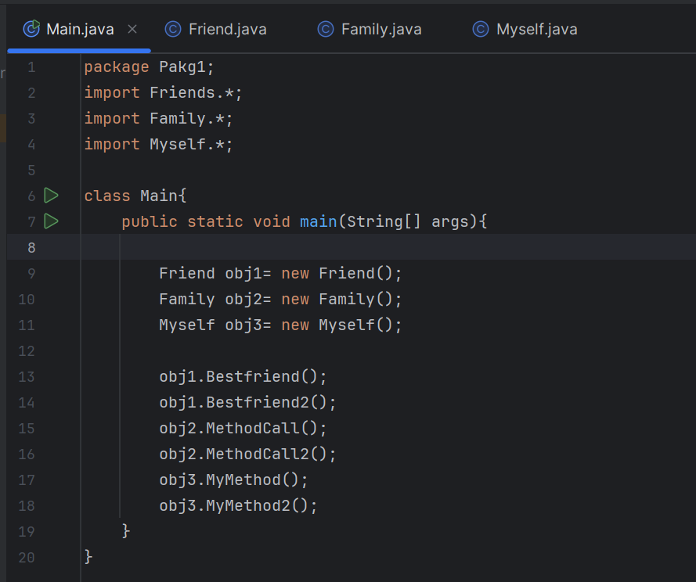

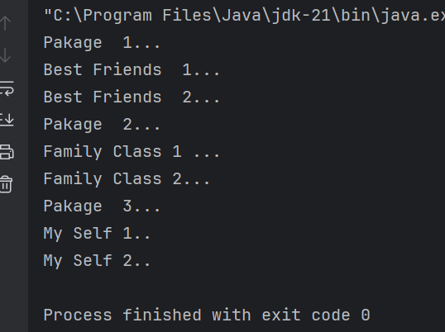
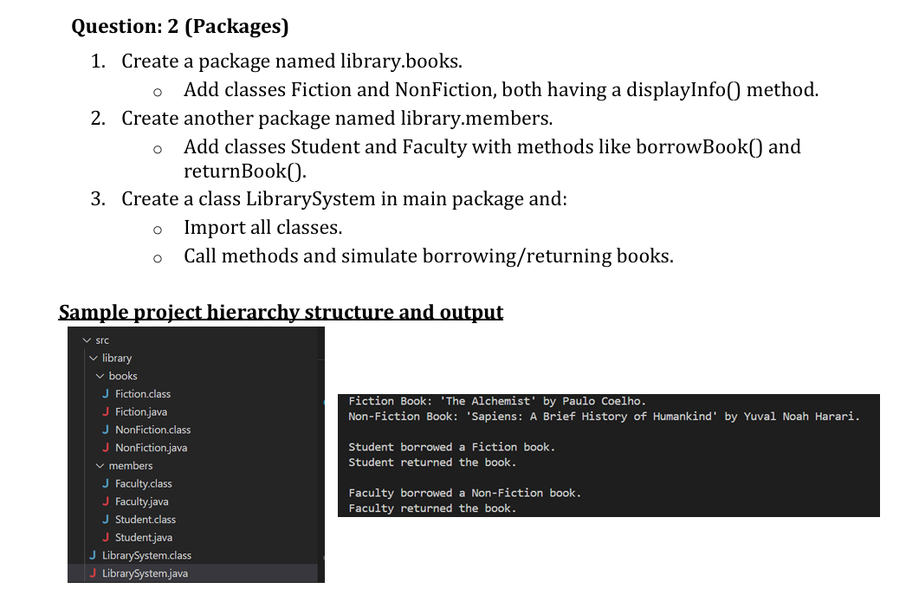
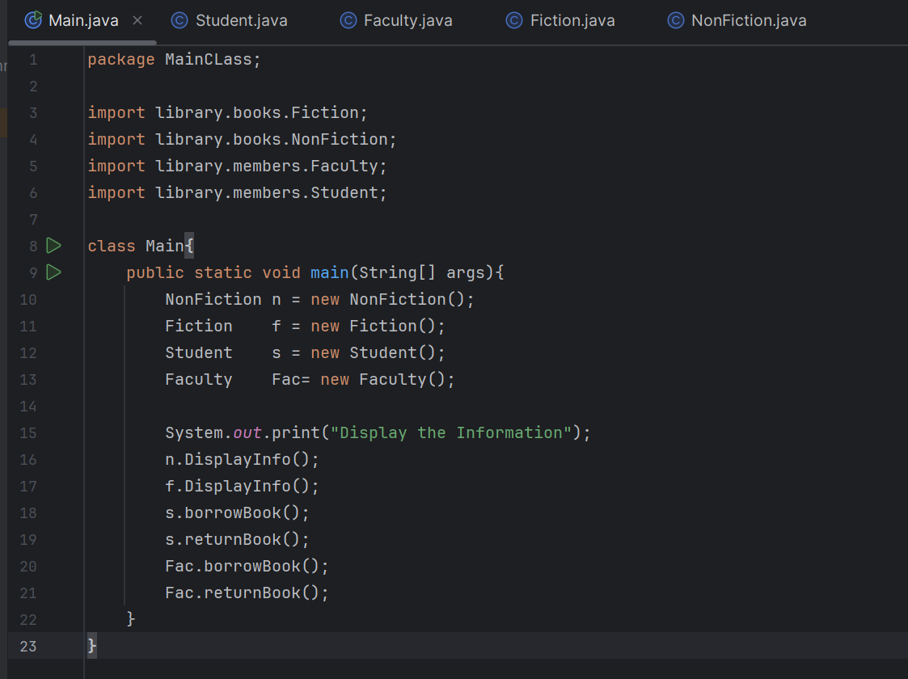
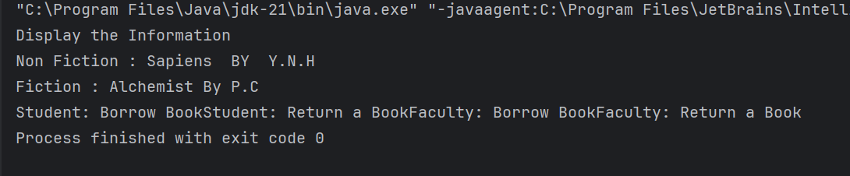
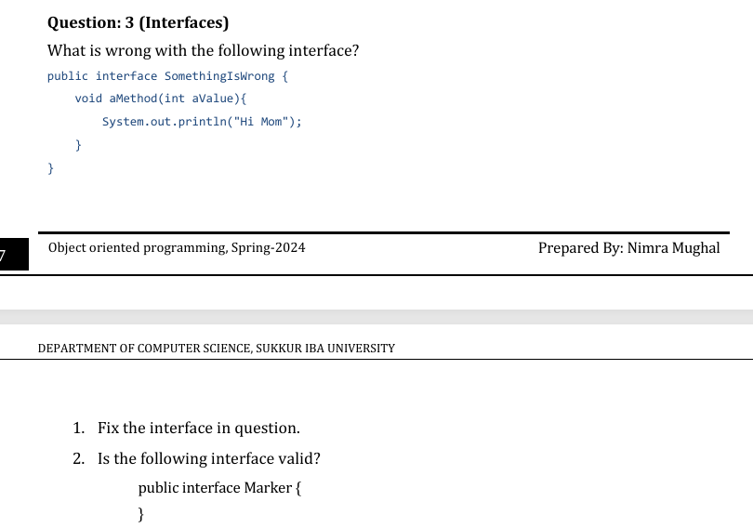
Interfaces cannot have method bodies (prior to Java 8) — unless the method is:
- default
- static
- private (Java 9+ only)
public interface SomethingIsWrong {
default void aMethod(int aValue) {
System.out.println("Hello World");
}
}
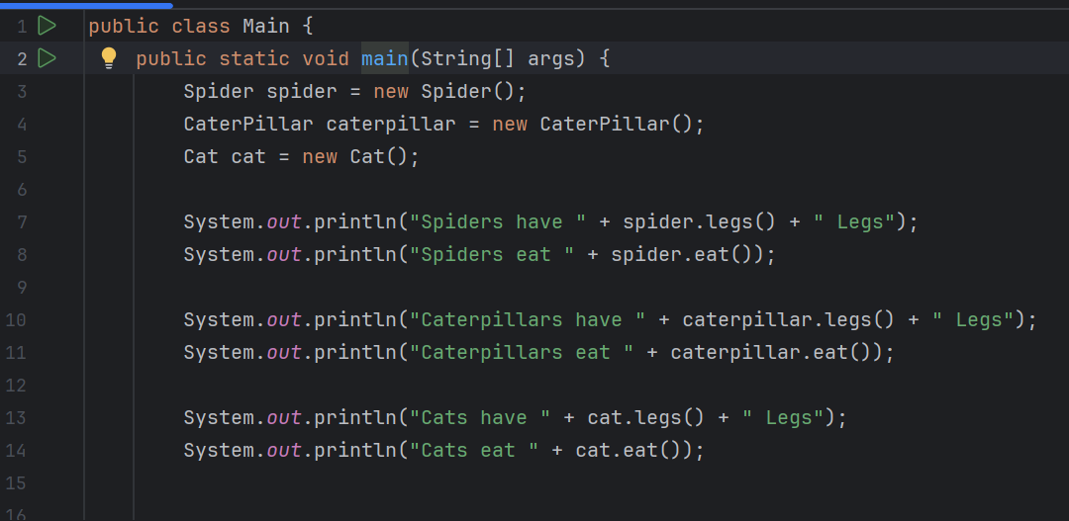
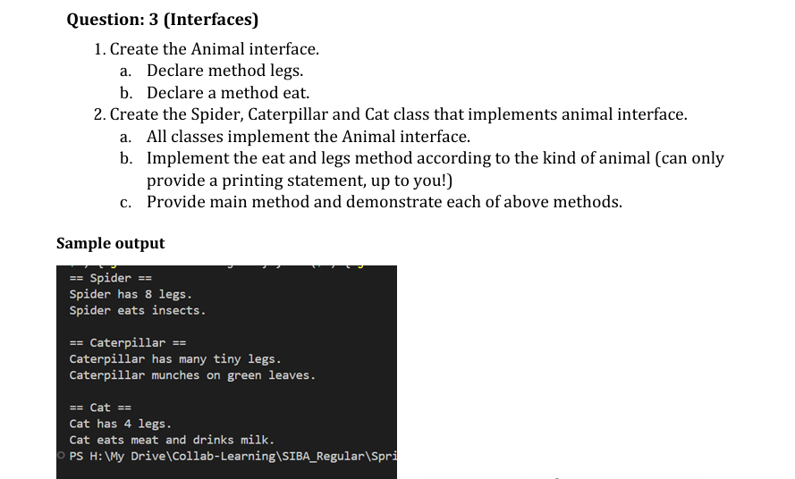
OUTPUT:
